Assignment: Web Development
For Learner Use:
Surname of Learner | NOMBILA
Name of Learner | EVILE
Learner ID | 0605250662083
Student Number | EN23CPT016
Date of Test Given | 09/09/2024
Location / Branch | iStudent Academy, Cape Town

For Assessors Use:
Name of Branch | Cape Town
Name of Facilitator

Name of Assessor

Assessor Number

Mark Allocation | 140
Mark Obtained

Competency Status (C / NYC)

Unit Standards MICT Seta | 115368 , 115372

Candidates Signature |  | Date of Submission | 23/09/2024
Assessors Signature |  | Date Marked

Assignment set up:

This assignment is made up of four tasks:

• Task A – Design a five page website
• Task B – Build a functioning five page website
• Task C – Test a functioning five page website
• Task D – Knowledge

Grading criteria
Pass – Candidates must achieve 84
Merit – Candidates must achieve 105
Distinction– Candidates achieve 120

Scenario
A local IT company has recently been set up in your home town which specialises in building high specification computers for gamers. They also sell computer games.

This company has asked if you could build a website to advertise their products and the top 10 computer games on the market at the moment.

Read all of the instructions carefully and complete the tasks in the order given.

Task A – Design a five-page website (45)

1 Prior to designing your website it is important that you understand exactly what is required of the website. Firstly, you will need to interview the owner of the computer shop to gain the following information (the assessor will act as the owner): (10)

• the aim and content/pages of the website
• any user requirements
•implementation of the website
• timescales for completing the website

Once you have this information you will need to produce a short plan that outlines the details you have learned.
INTERVIEW QUESTIONS
- What is the main goal of the website?
- What specific pages or sections do you want to include on the website?
- Do you have any specific content you want featured on each page?
- Who is your target audience?
- Are there any particular user interactions or functionalities you want to include?
- Are there any accessibility requirements or considerations?
- Do you have a preferred platform or technology for building the website (e.g., WordPress, HTML/CSS, a specific website builder)?
- Are there any existing brand guidelines or design elements (like logos or color schemes) that should be incorporated?
- Will you be providing the images and content, or should I source them?
- When do you need the website to be completed?
- Are there any important milestones or deadlines to be aware of?

IMPLEMENTATION PLAN (based on answers)

Aim and Content/Pages:
Goal: To advertise high-spec computers for gamers and showcase the top 10 computer games currently on the market.
Pages:
Home Page: Introduction to the company, highlights of top products and games.
Hardware Page: Detailed descriptions and images of high-spec computers.
Games Page: List and descriptions of the top 10 computer games.
About Us Page: Information about the company’s background, mission, and team.
Contact Us Page: Contact form, company address, phone number, and social media links.

User Requirements:
Target Audience: Gamers and tech enthusiasts.
Interactions: Product filtering, game reviews, and interactive features like a “build your own PC” tool.
Accessibility: Ensure text is readable, high contrast for visibility, and website is navigable via keyboard.

Implementation:
Technology: HTML and CSS for basic design, potentially using JavaScript for interactive features; WordPress for ease of updates and scalability.
Design Elements: Use existing logo, brand colours (e.g., dark themes with neon highlights), and fonts provided by the company.
Content: Company will provide product images and game details.
Timescales:
Completion Date: Three weeks from the start date.
Milestones:
- Week 1: Initial design approval and homepage development.
- Week 2: Development of product, games, and About Us pages.
- Week 3: Contact page, final testing, revisions, and launch preparation.

2 The computer company has initially asked you to design a five-page website that advertises the products and the top 10 computer games. The designs need to show the following: (35)

• layout of each page
• a navigation diagram/storyboard/flowchart showing navigation between pages when items are clicked
• the format of content including CSS
• at least 3 different interactive features
• at least ten images
• Any animation feature

*The plans can either be hand drawn or drawn using ICT. These will be additional digital or screenshot attachments to be submitted.

1. Layout of Each Page
- Home Page:
  - Introduction to the company.
  - Featured products.
  - Navigation bar linking to Products, Games, About Us, and Contact pages.
- Hardware Page:
  - A list of the company’s hardwares .
  - Each product has an image, name, price .
- Top 10 Games Page:
  - Display the top 10 computer games in a grid
  - Each game has a cover image, name, and short description .
- About Us Page:
  - Information about the company’s mission, team, and history.
  - Images of the team or office.
- Contact Page:
  - A form where visitors can submit inquiries (fields for name, email, and message)

2. Navigation Diagram/Storyboard/Flowchart

A flowchart that shows how users can navigate between the pages:
- Home Page links to all other pages.
- Clicking on a product image takes the user to a detailed product page.
- Clicking on a game image leads to the detailed game page.
- About Us and Contact pages link back to the home and other main pages via the navigation bar.

Task B – Build a functioning five-page website. (35)

1 Using the plans created in task A, build the functioning five-page website that advertises the products and shows the top 10 computer games.

Ensure your finished website includes the following:

• suitable CSS styling on each page
• five functioning structured pages
• At least ten images of products and all of the games
• navigation between each page
• three interactive features
• one animation.

*The actual code will be assessed as well as the functioning website. You need not build the website on a functioning registered domain – it can be local. This must be shown in Task C.

/index.html
/hardware.html
/games.html
/about.html
/contact.html

Task C – Test a functioning five-page website (10)

1 Now that your website is complete, complete the following tests: (10)

• functionality testing, open your website in two different web browsers
• test your navigation, demonstrating the functionality of each link
• test your interactive features.

Record any issues encountered for each below. Provide Screenshots.

MICROSOFT EDGE:
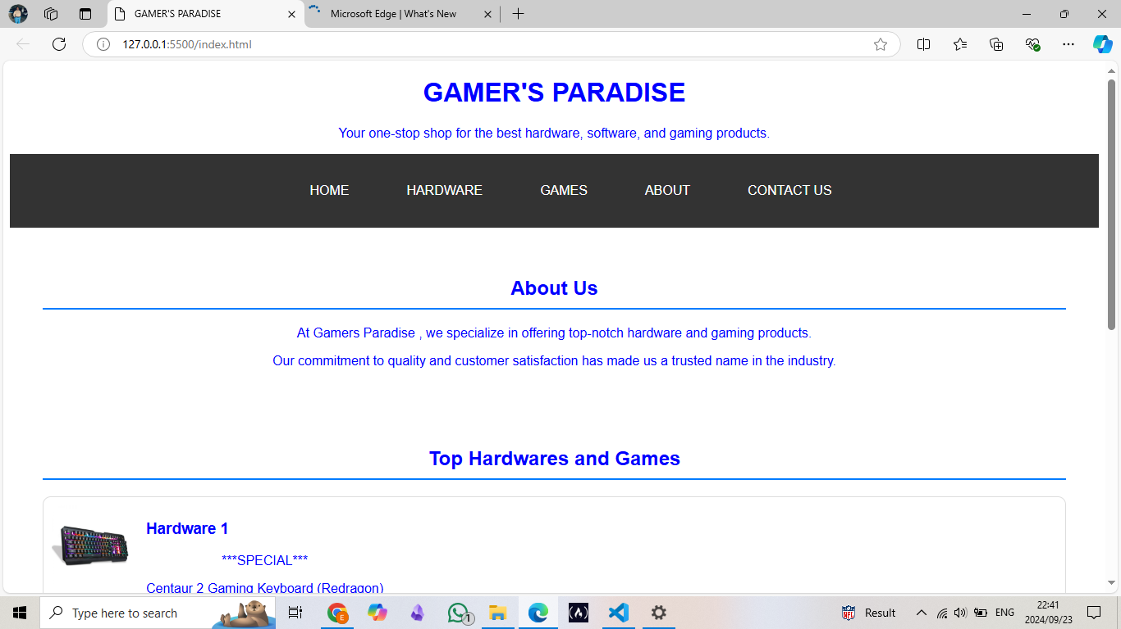
CHROME :
PAGE 1:
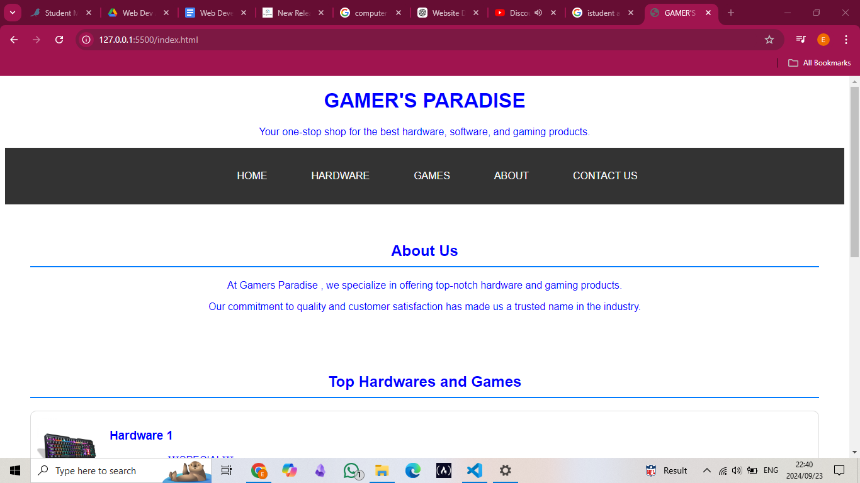
PAGE 2:
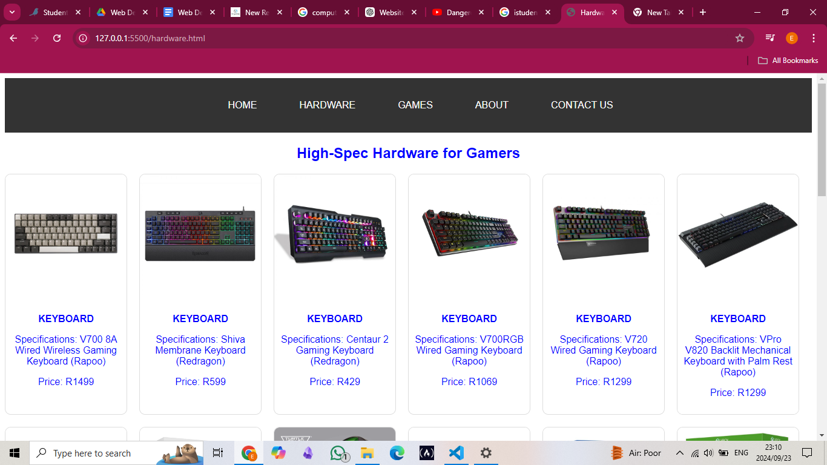
PAGE 3:
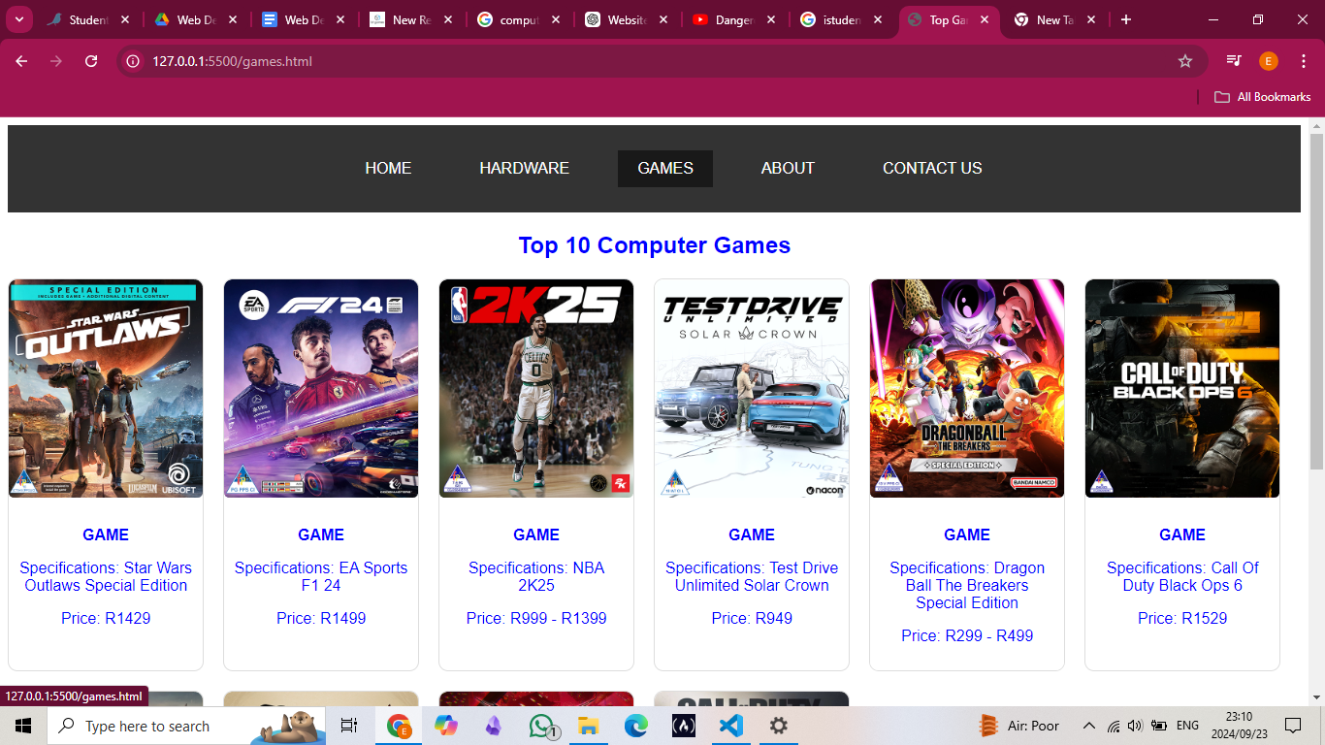
PAGE 4:

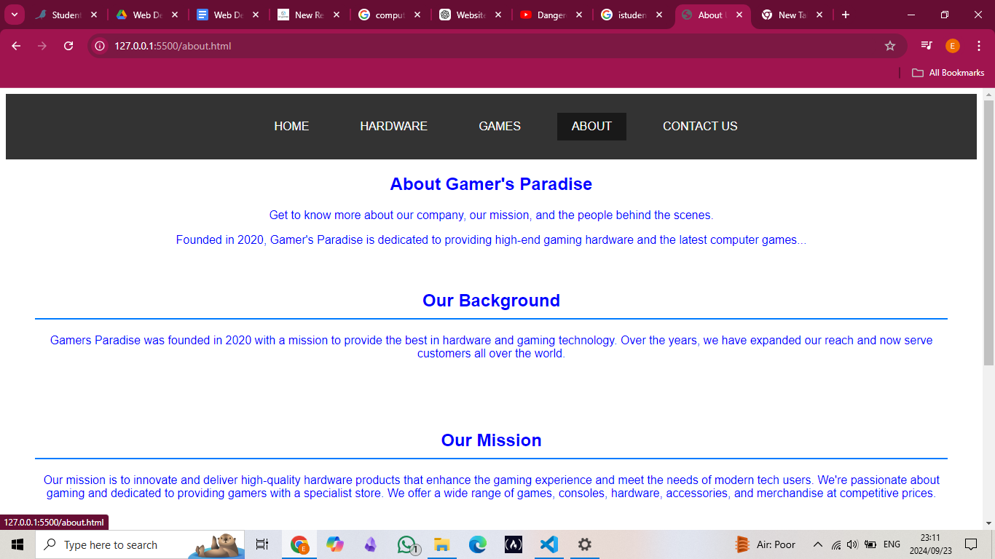
PAGE 5:

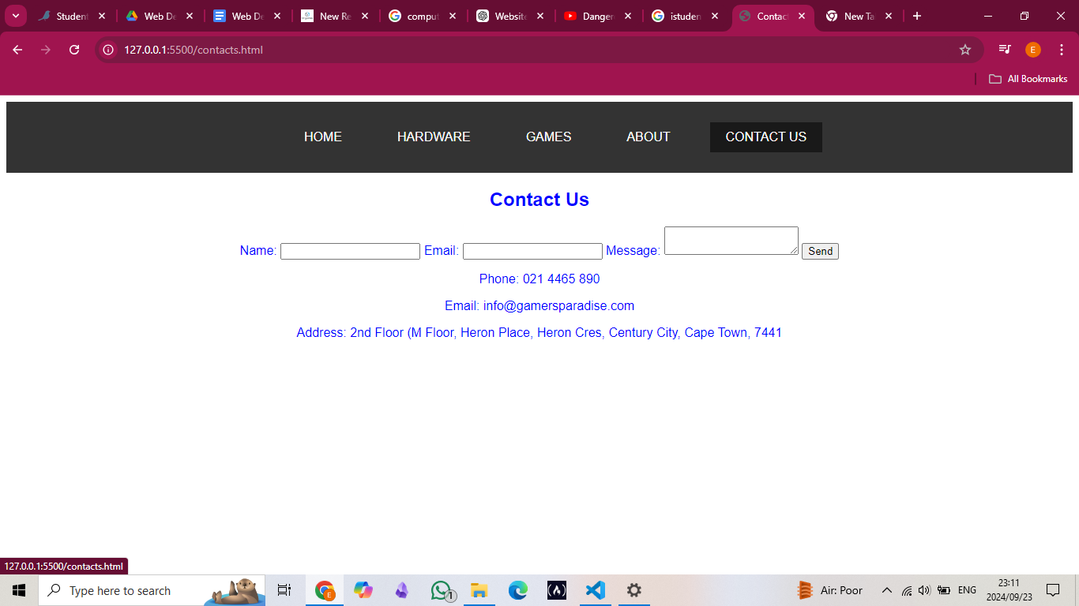

Task D – Theory (50)

Task D1: Describe three hardware and three software components that enable access to the web. (12)

Hardware Components
- Router : A router connects your local network to the internet, directing data packets between your devices and external servers.
- Modem : A modem converts digital data from your computer into signals for transmission over communication lines and vice versa, enabling internet access.
- Computer or Mobile Device : A computer or mobile device is needed to run web browsers or applications to access and interact with web content.

Software Components
- Web Browser : A web browser (e.g., Chrome) enables users to view and interact with web pages by interpreting HTML, CSS, and JavaScript.
- Operating System : An operating system (e.g., Windows) manages hardware resources and provides a platform for running web browsers and other applications.
- Network Protocols : Network protocols (e.g., TCP/IP, HTTP) define the rules for data transmission over the internet, ensuring proper communication between devices and servers.

Task D2: Explain the role of the following protocols: (6)

- TCP/IP including IPv6
- HTTP
- SMTP.

- TCP/IP is a set of protocols that manage data transmission over the internet. TCP ensures reliable and ordered data delivery, while IP handles addressing and routing. IPv6 is the latest version, offering a larger address space than IPv4 to accommodate more devices.

- HTTP is used for transferring web pages and data between a web server and a browser. It defines how requests and responses are formatted and transmitted, enabling communication over the World Wide Web.

- SMTP is used for sending emails from a client to an email server and between servers. It handles the process of email delivery, ensuring messages are routed to the correct recipient's server.

Task D3: Explain the role of the following: (6)
- Internet Service Provider
- Web hosting service
- Domain name registrar.

- An ISP provides individuals and organizations with access to the internet, connecting them through various technologies like broadband or fiber optics. They enable users to browse, stream, and communicate online.

- A web hosting service stores website files on servers and ensures that websites are accessible on the internet. They often offer additional services like domain registration and website security.

- A domain name registrar manages the registration of domain names, allowing users to purchase and maintain unique addresses (e.g: youtube.com) that identify their websites on the internet.

Task D4: Identify and briefly describe four types of web functionality. (8)

- User authentication verifies the identity of users, typically through login systems, ensuring that only authorized users can access specific areas or perform certain actions on a website.

- Form handling allows websites to collect and process user input through forms, enabling functionalities like data submission, registration, or feedback collection.

- Content management enables users to create, edit, and manage website content easily, often through a CMS, allowing updates without requiring technical expertise.

- Search functionality allows users to find specific content within a website by entering keywords, returning relevant results to enhance user navigation and experience.

Task D5: Explain the use of two different Mark-Up languages. (4)

- HTML( Hypertext Markup Language) is used to structure the content of web pages. It defines elements like headings, paragraphs, and links, allowing browsers to display text, images, and other media on the web.

- XML(eXtensible Markup Language) is used to store and transport data in a structured format. It is flexible and allows users to define their own tags, making it ideal for data exchange between different systems.

Task D6: Explain the use and functionality of: (8)
- Web runtime environments
- Web application programming languages
- Databases including SQL
- PHP

Web runtime environments, like Node.js, allow code (especially JavaScript) to be executed on the server side. They provide the necessary tools and libraries for running web applications, handling client-server communication, and managing asynchronous operations.

Web application programming languages are used to create both the front-end and back-end of web applications. Front-end languages like HTML, CSS, and JavaScript handle the user interface, while back-end languages like Python, Ruby, and PHP manage server-side logic, data processing, and database interactions.

Databases store and manage data for web applications. SQL is a standard language used to interact with relational databases like MySQL and PostgreSQL, allowing for data querying, retrieval, and manipulation in a structured format.

PHP is a server-side scripting language used to create dynamic web pages. It is embedded within HTML and is widely used for tasks like form handling, session management, and database interactions in web development.

Task D7: Identify one typical stack combination that can be used for web development. (2)
MERN stack is a typical combination used for web development. It consists of MongoDB (database), Express.js (back-end framework), React.js (front-end library), and Node.js (runtime environment).

Task D8: What is an API and describe a scenario where it would be required. (4)
An API (Application Programming Interface) is a collection of rules that enable various software programs to communicate and interact with one another. It specifies how requests and replies are submitted, allowing data and functionality to be transferred across systems.

For example, a mobile app that offers weather updates utilizes an API to obtain real-time weather data from a weather service. The app sends a request to the API, which returns the current weather information, allowing the app to display it to the user.

